Week 4
Spring REST using SpringBoot

Hands-on 1
Create a Spring Web Project using Maven
Steps Followed:
- Go to https://start.spring.io/
- Change Group as “com.cognizant”
- Change Artifact Id as “spring-learn”
- Select Spring Boot DevTools and Spring Web
- Create and download the project as zip
- Extract the zip in root folder to Eclipse Workspace
- Build the project using ‘mvn clean package
-Dhttp.proxyHost=proxy.cognizant.com -Dhttp.proxyPort=6050
-Dhttps.proxyHost=proxy.cognizant.com -Dhttps.proxyPort=6050
-Dhttp.proxyUser=123456’ command in command line
- Import the project in Eclipse "File > Import > Maven > Existing Maven Projects > Click Browse and select extracted folder > Finish"
- Include logs to verify if main() method of SpringLearnApplication. Run the SpringLearnApplication class.

Code – SpringLearnApplication.java
package com.cognizant.spring_learn;
import org.slf4j.Logger;
import org.slf4j.LoggerFactory;
import org.springframework.boot.SpringApplication;
import org.springframework.boot.autoconfigure.SpringBootApplication;

@SpringBootApplication
public class SpringLearnApplication {
private static final Logger LOGGER =
LoggerFactory.getLogger(SpringLearnApplication.class);
public static void main(String[] args) {
LOGGER.info("START");
SpringApplication.run(SpringLearnApplication.class, args);
LOGGER.info("END");
}
}

OUTPUT:
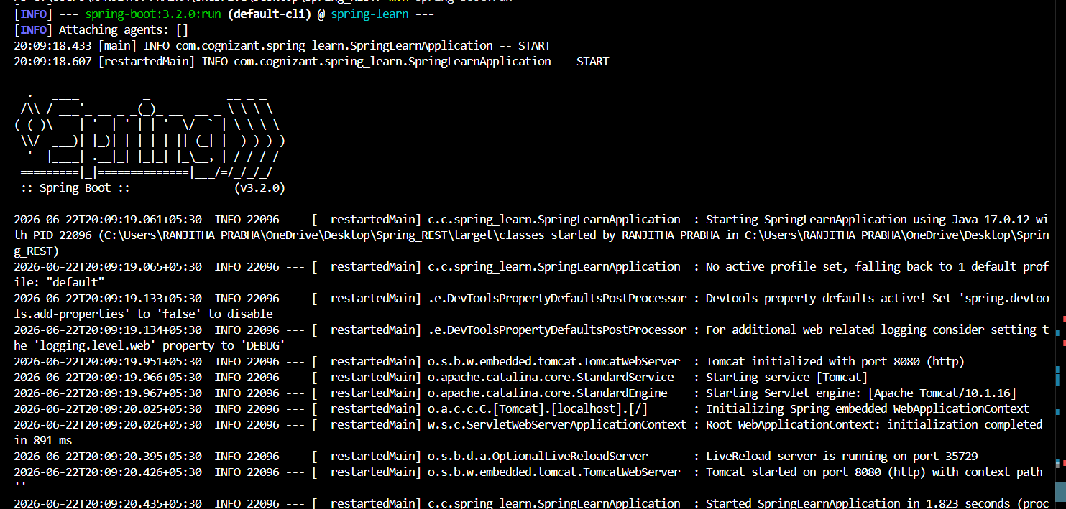
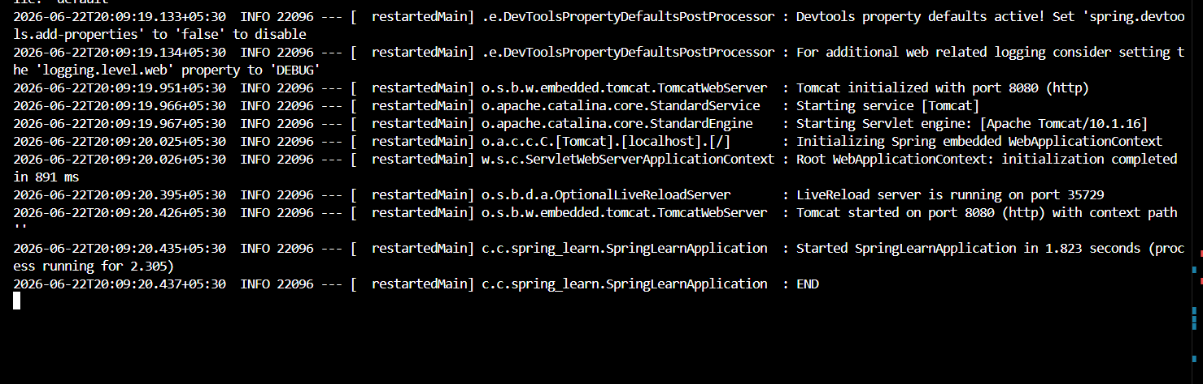

Hands-on 2
Spring Core – Load Country from Spring Configuration XML

Steps followed:
1. Created a Spring Boot project with Spring Web and DevTools. Created a Country class with a name property.
2. Added country.xml in src/main/resources and defined a Country bean.
3. Loaded the XML using ClassPathXmlApplicationContext in displayCountry() method.
4. Called displayCountry() from main() to print the loaded count

- Country.java
package com.cognizant.spring_learn;
import org.slf4j.Logger;
import org.slf4j.LoggerFactory;
public class Country {
private static final Logger LOGGER =
LoggerFactory.getLogger(Country.class);
private String code;
private String name;
public Country() {
LOGGER.debug("Inside Country Constructor.");
}
public String getCode() {
LOGGER.debug("Getting code: {}", code);
return code;
}
public void setCode(String code) {

LOGGER.debug("Setting code: {}", code);
this.code = code;
}
public String getName() {
LOGGER.debug("Getting name: {}", name);
return name;
}
public void setName(String name) {
LOGGER.debug("Setting name: {}", name);
this.name = name;
}
@Override
public String toString() {
return "Country{code='" + code + "', name='" + name + "'}";
}
}
2. country.xml
<?xml version="1.0" encoding="UTF-8"?>
<beans xmlns="http://www.springframework.org/schema/beans"
xmlns:xsi="http://www.w3.org/2001/XMLSchema-instance"
xsi:schemaLocation="
http://www.springframework.org/schema/beans
http://www.springframework.org/schema/beans/spring-beans.xsd">
<bean id="country" class="com.cognizant.spring_learn.Country">
<property name="code" value="IN" />
<property name="name" value="India" />
</bean>

</beans>
3. SpringLearnApplication.java
import org.springframework.context.ApplicationContext;
import org.springframework.context.support.ClassPathXmlApplicationContext;
public class SpringLearnApplication {
private static final Logger LOGGER =
LoggerFactory.getLogger(SpringLearnApplication.class);
public static void main(String[] args) {
LOGGER.info("START");
displayCountry();
LOGGER.info("END");
}
public static void displayCountry() {
ApplicationContext context =
new ClassPathXmlApplicationContext("country.xml");
Country country = context.getBean("country", Country.class);
LOGGER.debug("Country : {}", country.toString());
}
}
4. pom.xml
<dependency>
<groupId>org.springframework</groupId>
<artifactId>spring-context</artifactId>
</dependency>

OUTPUT:
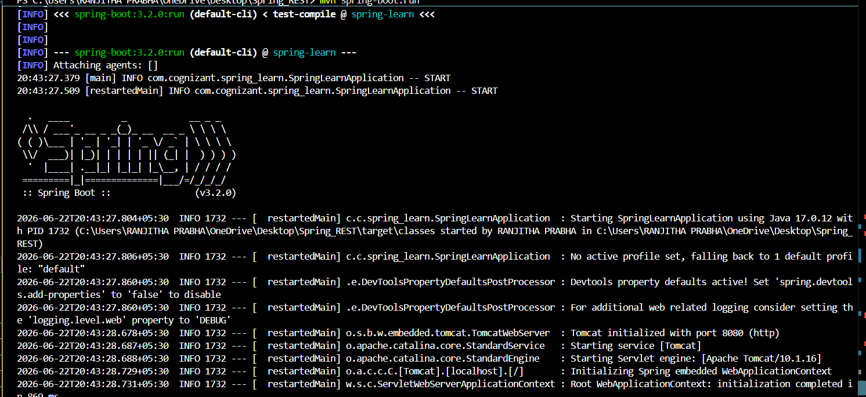
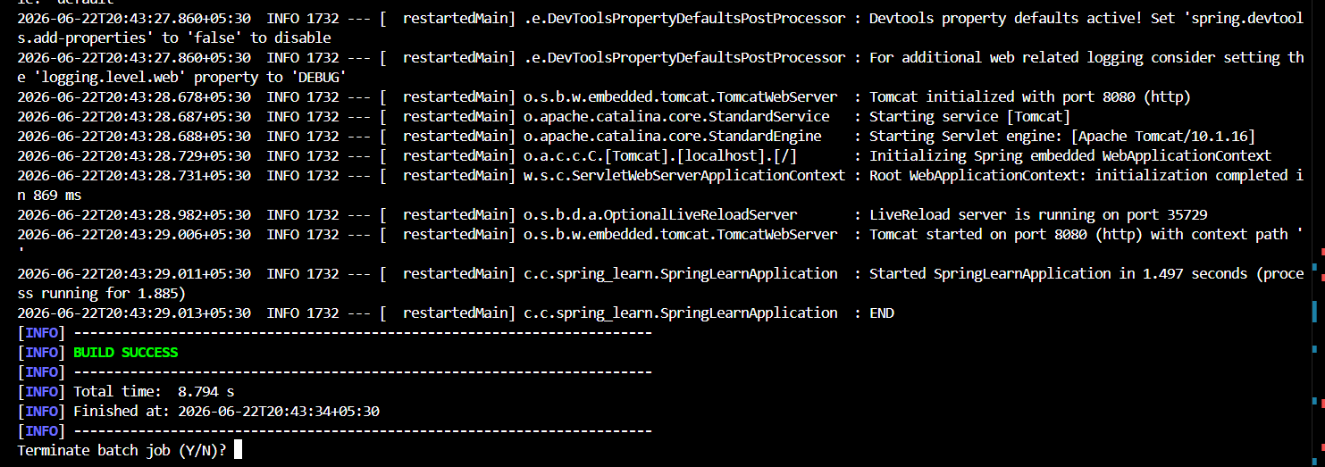

Hands-on 3
Hello World RESTful Web Service

Write a REST service in the spring learn application created earlier, that returns the text "Hello World!!" using Spring Web Framework. Refer details below:
Method: GET
URL: /hello

Controller: com.cognizant.spring-learn.controller.HelloController
Method Signature: public String sayHello()
Method Implementation: return hard coded string "Hello World!!"
Sample Request: http://localhost:8083/hello
Sample Response: Hello World!!

SOLUTION:
HelloController.java
package com.cognizant.spring_learn.controller;
import org.slf4j.Logger;
import org.slf4j.LoggerFactory;
import org.springframework.web.bind.annotation.GetMapping;
import org.springframework.web.bind.annotation.RestController;
@RestController
public class HelloController {
private static final Logger LOGGER =
LoggerFactory.getLogger(HelloController.class);
@GetMapping("/hello")
public String sayHello() {
LOGGER.info("START");
String message = "Hello World!!";
LOGGER.info("END");
return message;
}
}

OUTPUT:
Console Output
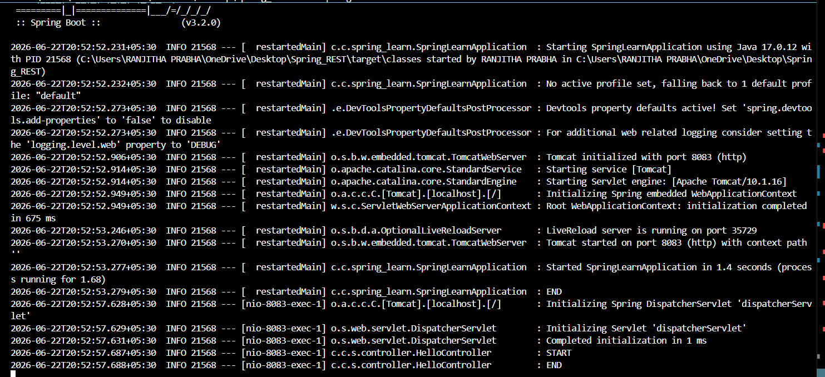
API Output in Web Browser
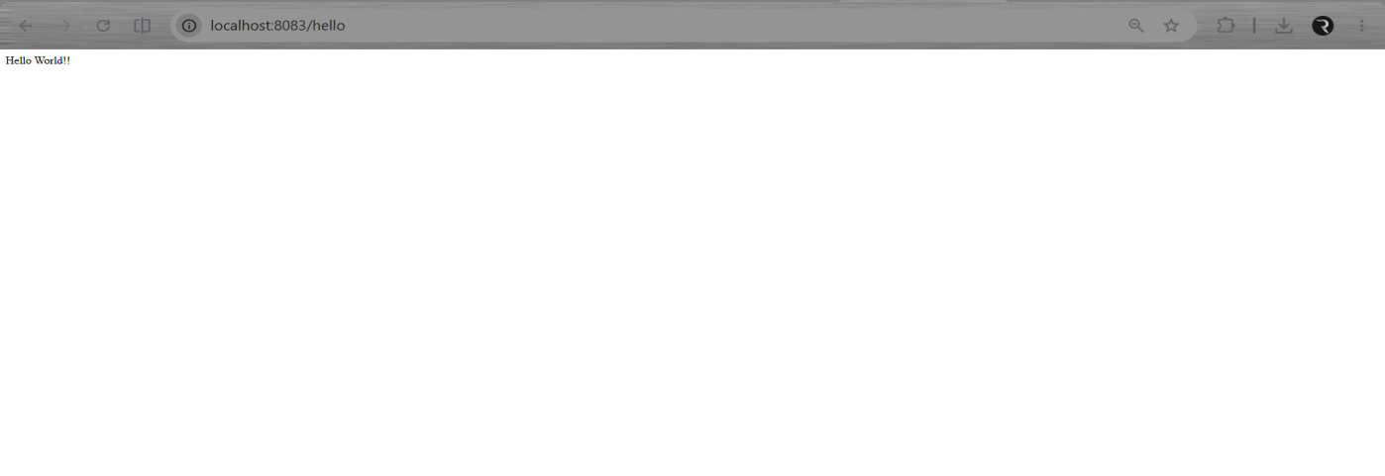
API Response in Postman
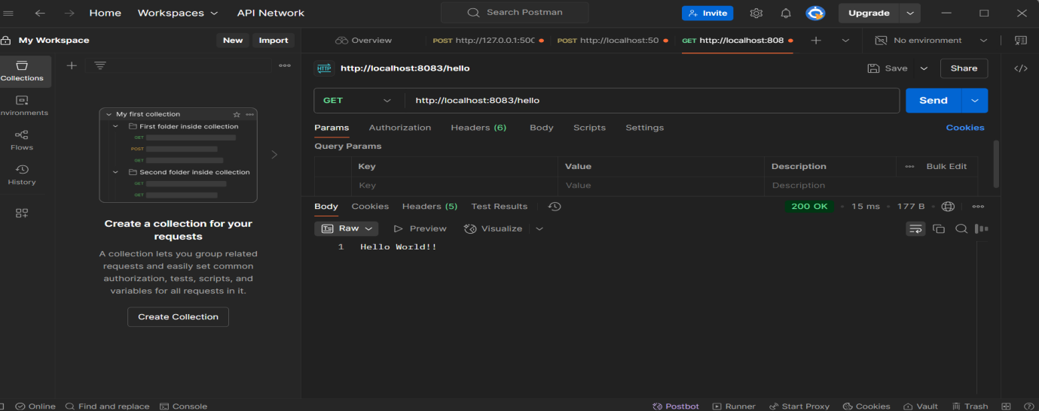

Hands-on 4
REST - Country Web Service

Write a REST service that returns India country details in the earlier created spring learn application
URL: /country
Controller: com.cognizant.spring-learn.controller.CountryController
Method Annotation: @RequestMapping
Method Name: getCountryIndia()
Method Implementation: Load India bean from spring xml configuration and return
Sample Request: http://localhost:8083/country
Sample Response:
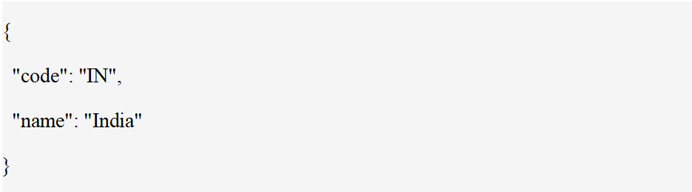

SOLUTION:
country.xml
<?xml version="1.0" encoding="UTF-8"?>
<beans xmlns="http://www.springframework.org/schema/beans"
xmlns:xsi="http://www.w3.org/2001/XMLSchema-instance"
xsi:schemaLocation="
http://www.springframework.org/schema/beans
http://www.springframework.org/schema/beans/spring-beans.xsd">
<bean id="country" class="com.cognizant.spring_learn.Country">
<property name="code" value="IN"/>
<property name="name" value="India"/>
</bean>
</beans>
CountryController.java
package com.cognizant.spring_learn.controller;
import com.cognizant.spring_learn.Country;
import org.slf4j.Logger;
import org.slf4j.LoggerFactory;
import org.springframework.context.ApplicationContext;
import org.springframework.context.support.ClassPathXmlApplicationContext;
import org.springframework.web.bind.annotation.RequestMapping;
import org.springframework.web.bind.annotation.RestController;
@RestController
public class CountryController {
private static final Logger LOGGER =
LoggerFactory.getLogger(CountryController.class);
@RequestMapping("/country")
public Country getCountryIndia() {
LOGGER.info("START");
ApplicationContext context =
new ClassPathXmlApplicationContext("country.xml");
Country country = context.getBean("country", Country.class);
LOGGER.info("END");
return country;
}
}
Country.java – Model Class
package com.cognizant.spring_learn;
public class Country {
private String code;
private String name;
public Country() {
System.out.println("Inside Country Constructor");
}
public String getCode() {
return code;
}
public void setCode(String code) {
this.code = code;
}
public String getName() {
return name;
}
public void setName(String name) {
this.name = name;
}
}
OUTPUT:
Console Output
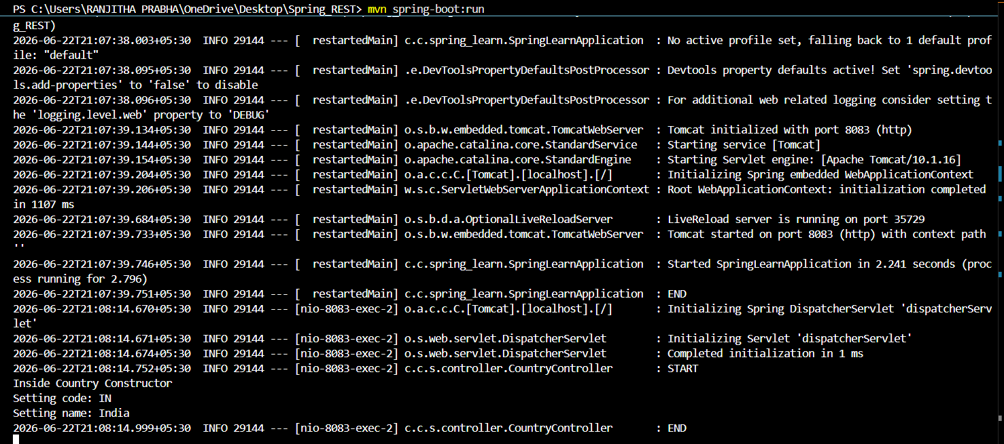
API Response in Postman
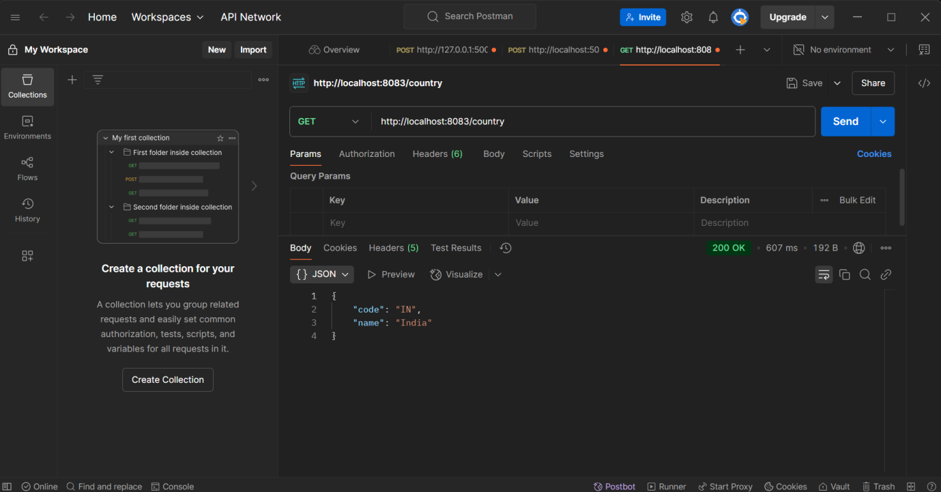
API Output in Web Browser
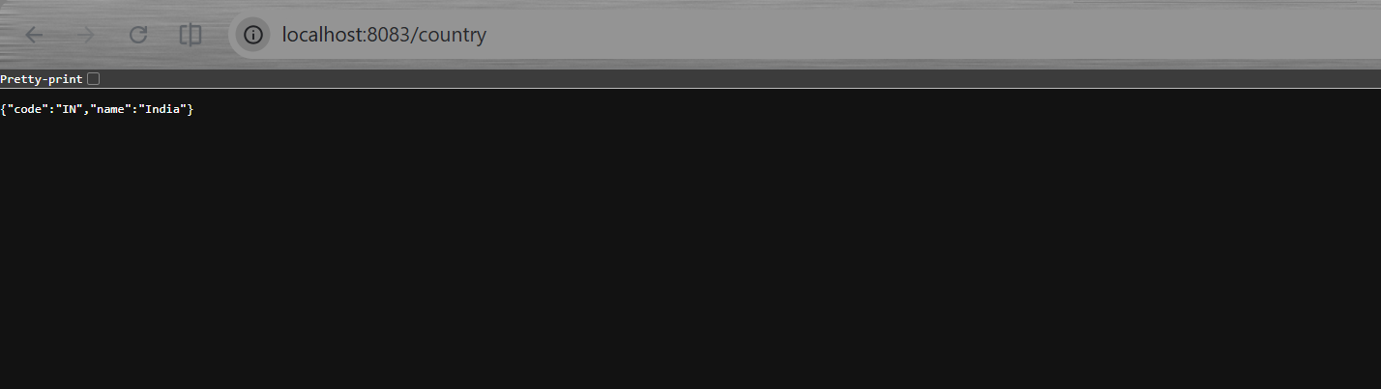

Hands-on 5
REST - Get country based on country code
Write a REST service that returns a specific country based on country code. The country code should be case insensitive.
Controller: com.cognizant.spring-learn.controller.CountryController
Method Annotation: @GetMapping("/countries/{code}")
Method Name: getCountry(String code)
Method Implemetation: Invoke countryService.getCountry(code)
Service Method: com.cognizant.spring-learn.service.CountryService.getCountry(String code)

Service Method Implementation:
- Get the country code using @PathVariable
- Get country list from country.xml
- Iterate through the country list
- Make a case insensitive matching of country code and return the country.
- Lambda expression can also be used instead of iterating the country list
Sample Request: http://localhost:8083/country/in
Sample Response:
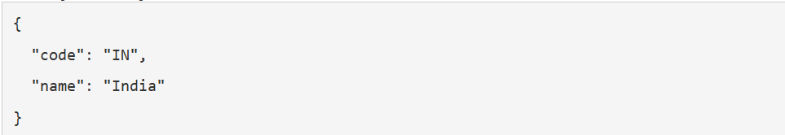

SOLUTION:
CountryService.java
package com.cognizant.spring_learn.service;
import com.cognizant.spring_learn.Country;
import org.springframework.context.ApplicationContext;
import org.springframework.context.support.ClassPathXmlApplicationContext;
import org.springframework.stereotype.Service;
import java.util.List;
@Service
public class CountryService {
public Country getCountry(String code) {
ApplicationContext context =
new ClassPathXmlApplicationContext("country.xml");
List<Country> countryList =
(List<Country>) context.getBean("countryList");

return countryList.stream()
.filter(c -> c.getCode().equalsIgnoreCase(code))
.findFirst()
.orElse(null);
}
}
CountryController.java
package com.cognizant.spring_learn.controller;
import com.cognizant.spring_learn.Country;
import com.cognizant.spring_learn.service.CountryService;
import org.slf4j.Logger;
import org.slf4j.LoggerFactory;
import org.springframework.beans.factory.annotation.Autowired;
import org.springframework.web.bind.annotation.*;
@RestController
public class CountryController {
private static final Logger LOGGER =
LoggerFactory.getLogger(CountryController.class);
@Autowired
private CountryService countryService;
@GetMapping("/countries/{code}")
public Country getCountry(@PathVariable String code) {
LOGGER.info("START");
Country country = countryService.getCountry(code);
LOGGER.info("END");
return country;
}
}
OUTPUT:
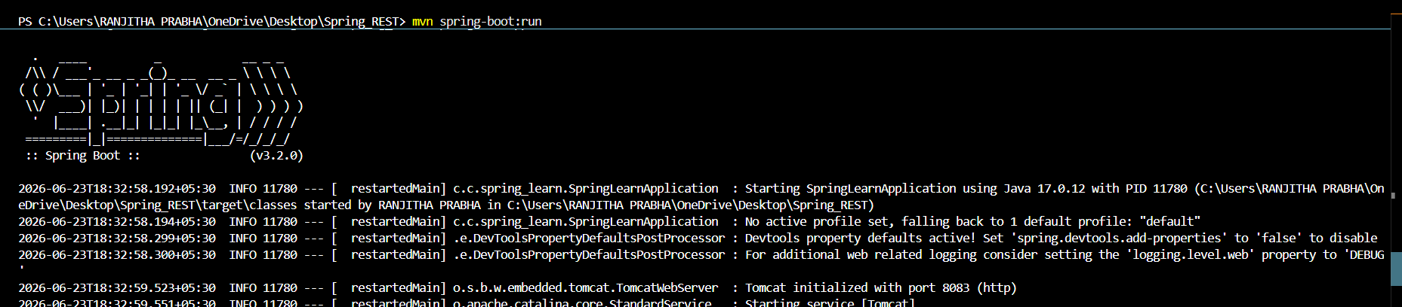
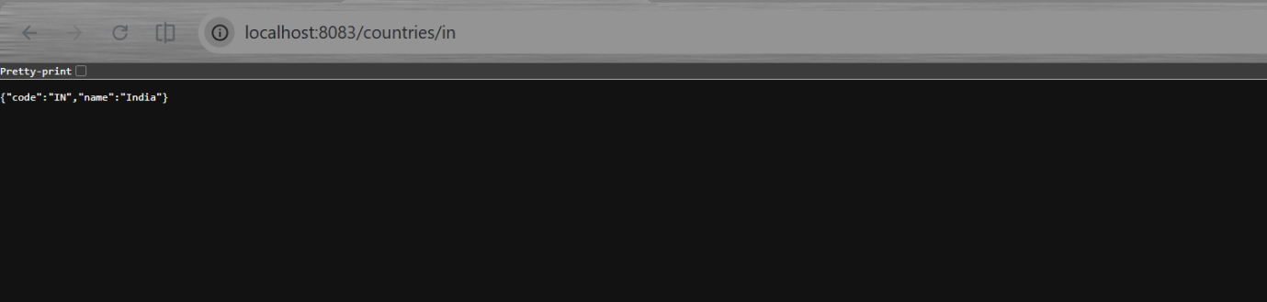
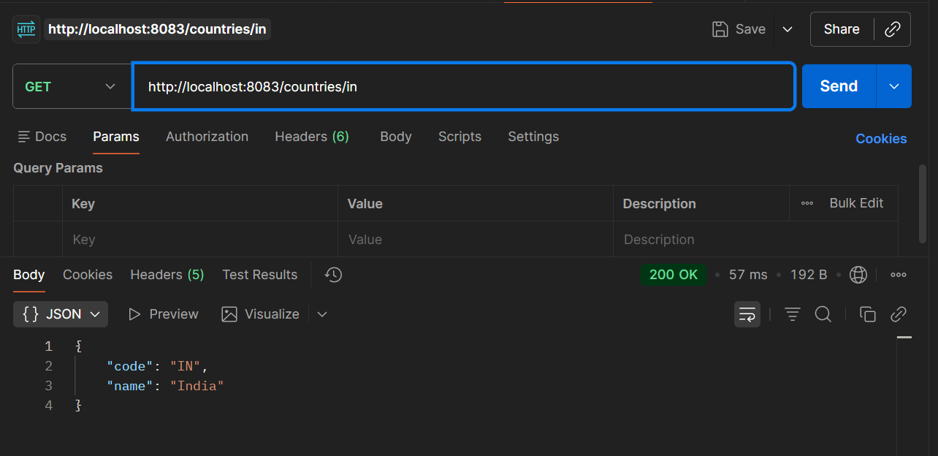

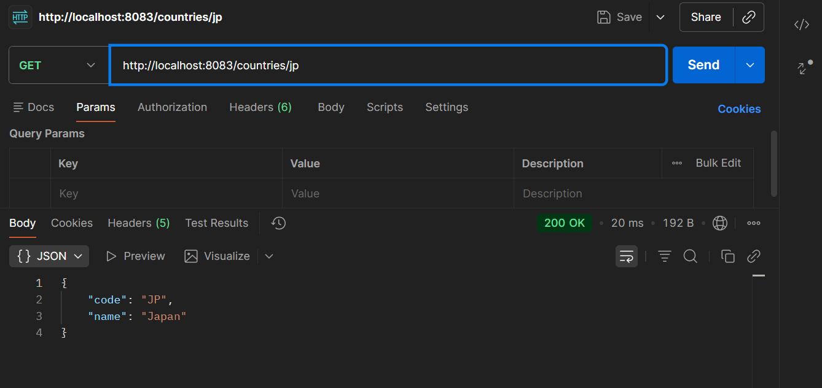

Hands on 6 - JWT
- Create authentication service that returns JWT
As part of first step of JWT process, the user credentials needs to be sent to authentication service request that generates and returns the JWT.
Ideally when the below curl command is executed that calls the new authentication service, the token should be responded. Kindly note that the credentials are passed using -u option.
Request
Response
This can be incorporated as three major steps:
- Create authentication controller and configure it in SecurityConfig
- Read Authorization header and decode the username and password
- Generate token based on the user retrieved in the previous step

SOLUTION:
pom.xml
<dependency>
<groupId>org.springframework.boot</groupId>
<artifactId>spring-boot-starter-security</artifactId>
</dependency>

<dependency>
<groupId>io.jsonwebtoken</groupId>
<artifactId>jjwt</artifactId>
<version>0.9.1</version>
</dependency>

AuthenticationController.java
package com.cognizant.spring_learn.controller;

import java.util.HashMap;
import java.util.Map;

import org.springframework.web.bind.annotation.GetMapping;
import org.springframework.web.bind.annotation.RestController;

@RestController
public class AuthenticationController {

@GetMapping("/authenticate")
public Map<String, String> authenticate() {

String token = "sample-jwt-token";

Map<String, String> response = new HashMap<>();
response.put("token", token);

return response;
}
}
SecurityConfig.java
package com.cognizant.spring_learn.config;

import org.springframework.context.annotation.Bean;
import org.springframework.context.annotation.Configuration;
import org.springframework.security.config.Customizer;
import org.springframework.security.config.annotation.web.builders.HttpSecurity;
import org.springframework.security.web.SecurityFilterChain;

@Configuration
public class SecurityConfig {

@Bean
public SecurityFilterChain securityFilterChain(HttpSecurity http)
throws Exception {

http
.authorizeHttpRequests(auth -> auth
.anyRequest().authenticated())
.httpBasic(Customizer.withDefaults());

return http.build();
}
}
application.properties
server.port=8090

OUTPUT:
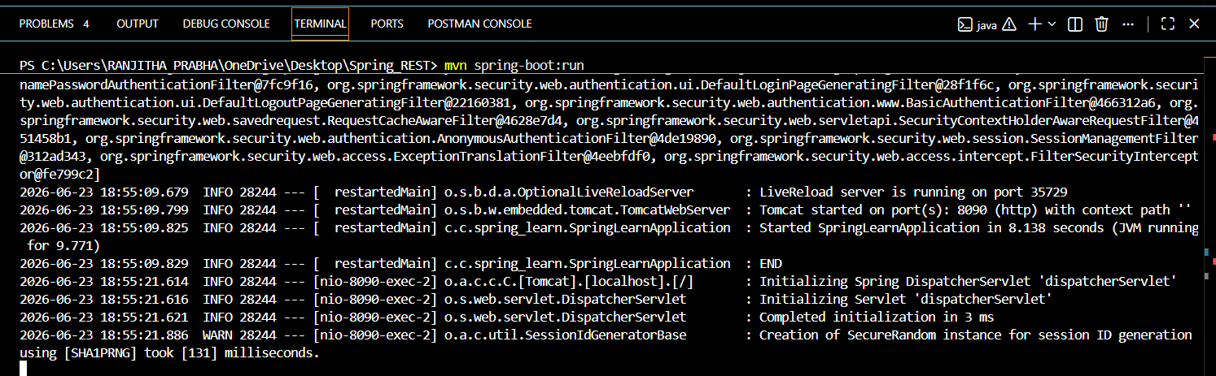

- Read Authorization header and decode the username and password
AuthenticationController.java
package com.cognizant.spring_learn.controller;

import java.nio.charset.StandardCharsets;
import java.util.Base64;
import java.util.HashMap;
import java.util.Map;

import javax.servlet.http.HttpServletRequest;

import org.springframework.web.bind.annotation.GetMapping;
import org.springframework.web.bind.annotation.RestController;

@RestController
public class AuthenticationController {

@GetMapping("/authenticate")
public Map<String, String> authenticate(HttpServletRequest request) {

String authHeader = request.getHeader("Authorization");

String encodedCredentials = authHeader.substring(6);

byte[] decodedBytes =
Base64.getDecoder().decode(encodedCredentials);

String credentials =
new String(decodedBytes, StandardCharsets.UTF_8);

String[] values = credentials.split(":");

String username = values[0];
String password = values[1];

System.out.println("Username: " + username);
System.out.println("Password: " + password);

Map<String, String> response = new HashMap<>();
response.put("token", "sample-jwt-token");

return response;
}
}

OUTPUT:
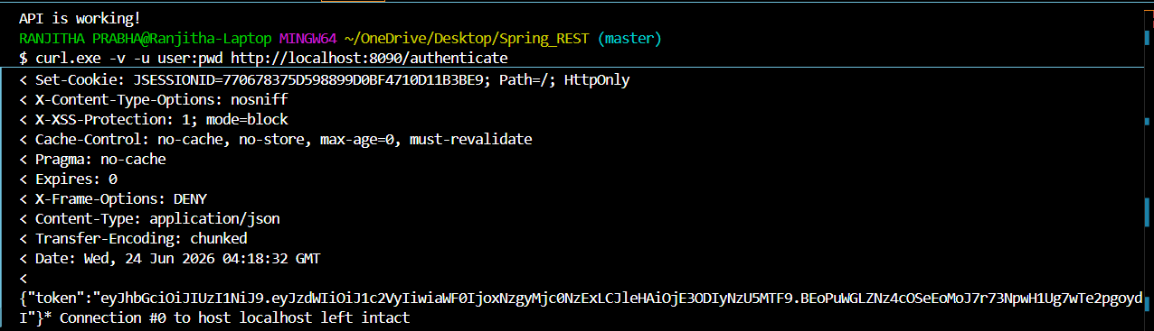

- Generate token based on the user
AuthenticationResponse.java
package com.cognizant.spring_learn;

public class AuthenticationResponse {

private String token;

public AuthenticationResponse(String token) {
this.token = token;
}

public String getToken() {
return token;
}

public void setToken(String token) {
this.token = token;
}
}
AuthenticationController.java
package com.cognizant.spring_learn.controller;

import java.nio.charset.StandardCharsets;
import java.util.Base64;

import javax.servlet.http.HttpServletRequest;

import org.springframework.web.bind.annotation.GetMapping;
import org.springframework.web.bind.annotation.RestController;

import com.cognizant.spring_learn.AuthenticationResponse;

@RestController
public class AuthenticationController {

@GetMapping("/authenticate")
public AuthenticationResponse authenticate(HttpServletRequest request) {

String authHeader = request.getHeader("Authorization");

String encodedCredentials = authHeader.substring("Basic ".length());

byte[] decodedBytes = Base64.getDecoder().decode(encodedCredentials);

String credentials = new String(decodedBytes, StandardCharsets.UTF_8);

String username = credentials.split(":")[0];
String password = credentials.split(":")[1];

System.out.println("Username: " + username);
System.out.println("Password: " + password);

String token = "sample-jwt-token-for-" + username;

return new AuthenticationResponse(token);
}
}
pom.xml
<?xml version="1.0" encoding="UTF-8"?>
<project xmlns="http://maven.apache.org/POM/4.0.0"
xmlns:xsi="http://www.w3.org/2001/XMLSchema-instance"
xsi:schemaLocation="http://maven.apache.org/POM/4.0.0 https://maven.apache.org/xsd/maven-4.0.0.xsd">
<modelVersion>4.0.0</modelVersion>
<parent>
<groupId>org.springframework.boot</groupId>
<artifactId>spring-boot-starter-parent</artifactId>
<version>2.7.18</version>
<relativePath/>
</parent>
<groupId>com.cognizant</groupId>
<artifactId>spring-rest</artifactId>
<version>0.0.1-SNAPSHOT</version>
<properties>
<java.version>17</java.version>
</properties>
<dependencies>

<dependency>
<groupId>org.springframework.boot</groupId>
<artifactId>spring-boot-starter-web</artifactId>
</dependency>

<dependency>
<groupId>org.springframework.boot</groupId>
<artifactId>spring-boot-starter-security</artifactId>
</dependency>

<dependency>
<groupId>io.jsonwebtoken</groupId>
<artifactId>jjwt-api</artifactId>
<version>0.11.5</version>
</dependency>

<dependency>
<groupId>io.jsonwebtoken</groupId>
<artifactId>jjwt-impl</artifactId>
<version>0.11.5</version>
<scope>runtime</scope>
</dependency>

<dependency>
<groupId>io.jsonwebtoken</groupId>
<artifactId>jjwt-jackson</artifactId>
<version>0.11.5</version>
<scope>runtime</scope>
</dependency>
</dependencies>
<build>
<plugins>
<plugin>
<groupId>org.springframework.boot</groupId>
<artifactId>spring-boot-maven-plugin</artifactId>
</plugin>
</plugins>
</build>
</project>
JwtRequest.java
package com.cognizant.spring_learn.model;
public class JwtRequest {
private String username;
private String password;
public JwtRequest() {
}
public JwtRequest(String username, String password) {
this.username = username;
this.password = password;
}
public String getUsername() {
return username;
}
public void setUsername(String username) {
this.username = username;
}
public String getPassword() {
return password;
}
public void setPassword(String password) {
this.password = password;
}
}
JwtResponse.java
package com.cognizant.spring_learn.model;
public class JwtResponse {
private String token;
public JwtResponse(String token) {
this.token = token;
}
public String getToken() {
return token;
}
public void setToken(String token) {
this.token = token;
}
}
JwtUtil.java
package com.cognizant.spring_learn.util;
import java.nio.charset.StandardCharsets;
import java.security.Key;
import java.util.Date;
import io.jsonwebtoken.Jwts;
import io.jsonwebtoken.SignatureAlgorithm;
import io.jsonwebtoken.security.Keys;
public class JwtUtil {
private static final String SECRET_KEY =
"secretkey123456secretkey123456secretkey123456";
// must be long enough
private static final Key key =
Keys.hmacShaKeyFor(SECRET_KEY.getBytes(StandardCharsets.UTF_8));
public static String generateToken(String username) {
return Jwts.builder()
.setSubject(username)
.setIssuedAt(new Date())
.setExpiration(new Date(System.currentTimeMillis() + 1000 * 60 * 20))
.signWith(key, SignatureAlgorithm.HS256)
.compact();
}
}
OUTPUT:
